Lesson 4 Demo 16: Scale Up an Application with More Replicas

This section will guide you to:

* Scale up an application with more replicas

This lab has one sub-section, namely:

1. Scaling up an application with more replicas

**Note:** If you don’t have an existing Kubernetes cluster, refer to the Demo 1.1 of Lesson 1.

**Step 1:** Scaling up an application with more replicas

* Start the kubernetes cluster in the lab
* The docker scale command enables you to scale one or more replicated services either up or down to the desired number of replicas. This command cannot be applied on services which are in the global mode. The command will return immediately but the actual scaling of the service may take some time. To stop all the replicas of a service while keeping the service active in the swarm, you can set the scale to 0
* You can install docker with **sudo apt install docker**
* Let's start with scaling a single service. As the first step, startdocker *swarm init* as shown below to access docker services:  
  *sudo docker swarm init*

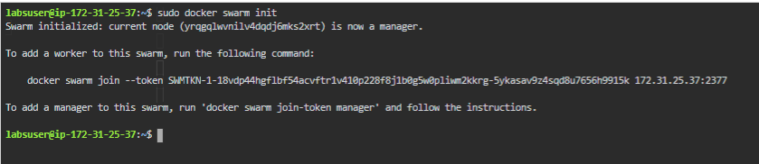

* Create a service using docker commands as shown below:

*sudo docker service create --mode replicated --name frontend gcr.io/google-samples/gb-frontend:v4*

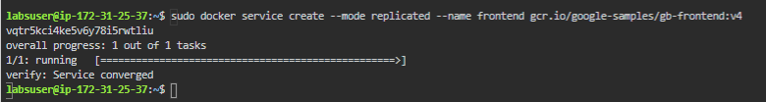

* Let's now scale up the service using the following command that scales the frontend service to 50 tasks:  
    
  *sudo docker service scale frontend=5  
    
  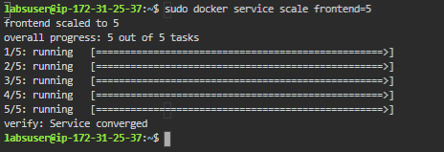*
* Let's create another service backend and work on multiple services as shown below:

*sudo docker service create --mode replicated --name backend redis*

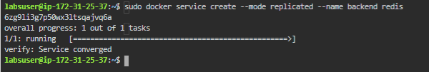

* The docker service scale command allows you to set the desired number of tasks for multiple services at once. The following example scales both the backend and frontend services and lets you scale the multiple services at once as shown below:  
    
  *sudo docker service scale backend=3 frontend=2*

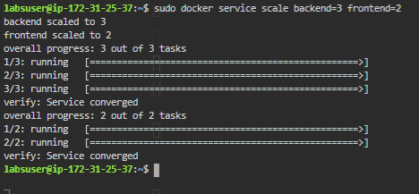

* You can verify the services ReplicaSet using the docker command as shown below:

*sudo docker service ls*

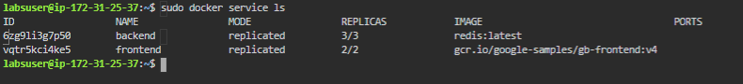

* This is how you can scale up an application with more replicas
* You can remove the services with **sudo docker service rm frontend backend**